An Empirical Study of Mamba
Yesheng Guan(yguan29), Runming Zeng(rzeng21), Dequan Zhang(dzhan148)
Introduction
Recent advances in sequence modeling have been dominated by Transformer-based architectures. However, their quadratic complexity in sequence length limits efficiency, especially for long-context tasks. The paper “Mamba: Linear-Time Sequence Modeling with Selective State Spaces” introduces a new architecture, Mamba. Mamba is a proposed sequence model that aims to replace the attention mechanism used in Transformers. Instead of comparing every token with others, Mamba maintains a running memory that is updated step by step, which allows it to process long sequences with linear time complexity. A key and interesting innovation of Mamba is its selective mechanism, where parameters such as Delta and C depend on the input, enabling the model to decide what information to keep, forget, or use for prediction.
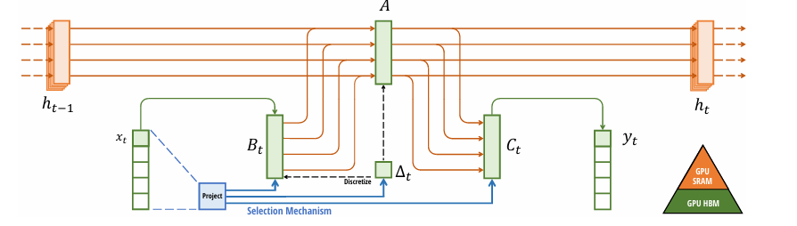Figure 1: Mamba model
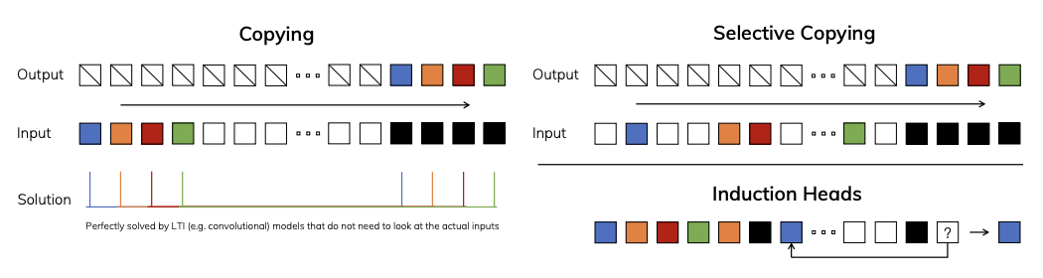
Figure 2: Comparison between copying and selective copying
Based on the paper and in this project, we reimplement and empirically evaluate the Mamba architecture using the official framework, and compare it against a Transformer baseline (Pythia-160M). Beyond reproducing key claims from the paper, we extend the study by analyzing robustness, long-sequence behavior, and the role of Mamba’s selective mechanisms(Selective Delta and Selective C).

Methodology
Datasets and Preprocessing
Three datasets were used across different experiments:
PubMedQA (pqa_artificial split): A biomedical question answering dataset sourced from PubMed abstracts. Each example contains a research question, one or more supporting context passages. For evaluation, we sampled 200 examples from the training split. In Claim 1 experiment, prompts with token separators until reaching the exact target token count (512, 1024, 2048 and 4096). We used the NeoX tokenizer for both Mamba and the Pythia. In Claim 2, each example was formatted into a prompt template consisting of a task instruction, the context passage, the question, and an answer. All inputs were truncated to 2048 tokens. In the distribution shift, the answer choices range from [yes, no, maybe] to [maybe, yes, no]. All other steps were identical to the standard evaluation.In Hypothesis 2, PubMedQA examples were chunked into non-overlapping fixed-length blocks (64, 128 and 256). A subset of 500 training blocks and 100 validation blocks was used to keep training tractable within available computers.
WikiText-2 (wikitext-2-raw-v1, test split): A standard English language modeling benchmark derived from Wikipedia articles. In Hypothesis 1, we filtered to passages longer than 100 characters and concatenated the first 10 into a single evaluation document. The concatenated WikiText-2 document was preprocessed by randomly inserting out-of-vocabulary filler tokens ("blahblah", "xyzxyz", "dummytext", etc.) at uniformly random word positions. Filler ratios of 0%, 10%, 30%, and 50% were tested. The noisy document was then truncated to 1024 tokens and perplexity was measured.

Challenges
One of the important challenges for our project was selecting appropriate datasets for evaluation. The original Mamba paper has results on a collection of general-domain benchmarks, but these datasets are not always straightforward to reproduce or directly comparable in our environment. Besides, we faced challenges in the implementation and training of the simplified Mamba variants for the ablation study. Unlike the pre-trained models, these variants had to be trained from scratch with limited computational resources.

Results
The results of our experiments provide strong evidence supporting the advantages of the Mamba architecture. For benchmarks with long sequences, we get that generation time of Mamba increases more slowly compared to the Transformer baseline, and the Transformer shows a sharp increase in latency when the input length grows from 512 to 4096 tokens. This verifies the first claim and the expected linear-time scaling behavior of Mamba, in contrast to the quadratic scaling of Transformers.

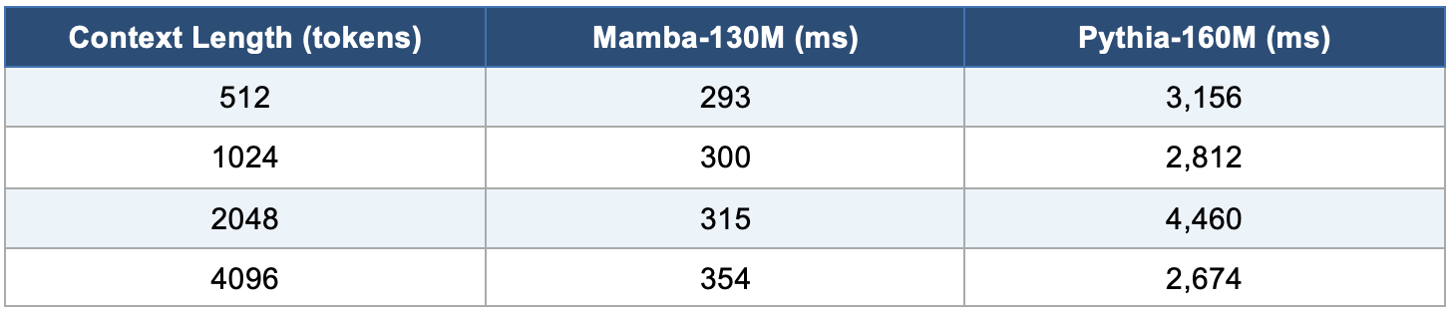
Table 1: Generation Time for Mamba and Pythia under different tokens
For the second claim, in the zero-shot evaluation on PubMedQA dataset, the claim that Mamba-130M achieves higher average accuracy than Pythis-160M is not supported. This result points out that, using the default prompt format (“yes, no, maybe”), the Transformer baseline (Pythia-160M) achieves an accuracy of 0.595, outperforming Mamba-130M, which achieves 0.485 (Figure 1). However, when we introduce a distribution shift in the prompt format, changing the answer order from (“yes, no, maybe”) to (“maybe, yes, no”), the performance of the models changes significantly. Under this shifted prompt, Pythia’s accuracy drops from 0.595 to 0.500, indicating sensitivity to prompt structure. In contrast, Mamba’s accuracy increases substantially from 0.485 to 0.645, which is better than the Transformer baseline.
So, these findings suggest that Mamba may not outperform Transformers in standard zero-shot evaluation on certain dataset, and the original claim is not supported in a strict sense on PubMedQA, which also the article does not tell us.
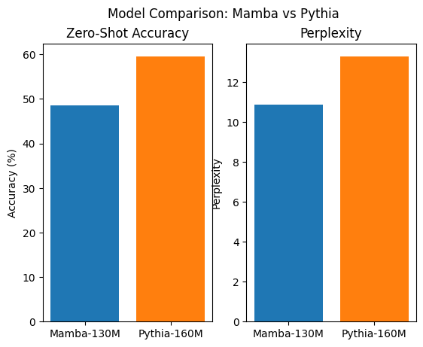
Figure 3: Zero-shot evaluation between Mamba and Pythia

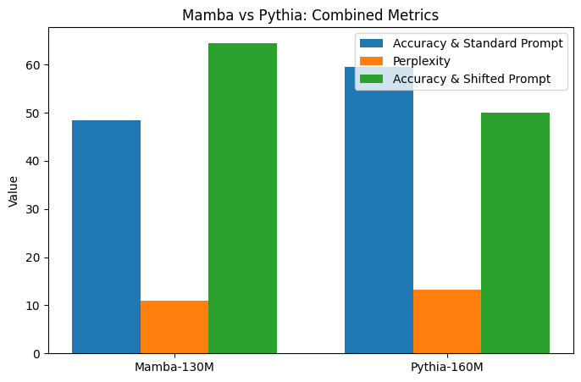
Figure 4: Mamba vs Pythia: Accuracy and Perplexity Under Prompts

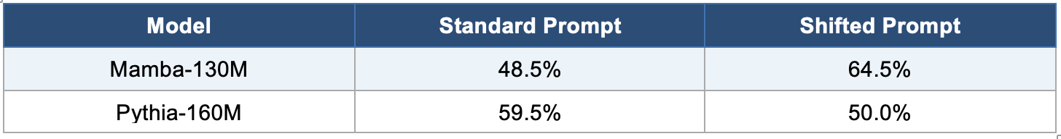
Table 2: Accuracy Comparison Under Standard and Shifted Prompts

For the hypothesis, the robustness experiment provides strong empirical support for the hypothesis that Mamba is more resilient to irrelevant input compared to the Transformer baseline. When no filler text is added (filler ratio is 0%), both models perform equally, serving as a baseline with a normalized perplexity of 1.00. However, as the proportion of irrelevant filler text increases, the performance of the two models diverges significantly. From the results, we can get, at 30% filler, Mamba shows a modest increase to 1.07, while the Transformer jumps to 5.41. These results demonstrate that Mamba’s performance degrades minimally even under heavy noise, while the Transformer is highly sensitive to irrelevant tokens, and the hypothesis can be supported.
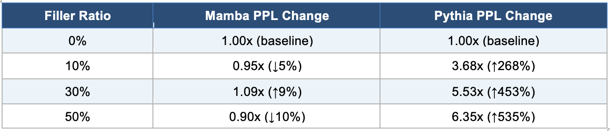
Table 3: Perplexity Change for Mamba and Pythia under different Filler Ration
Also, the ablation study results provide ideas about the contribution of Mamba’s selective mechanisms, which are Selective Delta and Selective C. Among the four model variants tested, the variant using only Selective Delta achieves a lowest perplexity of 1496.07, which is slightly lower than the perplexity value for model with using both Selective Delta and Selective C. Overall, these results show that removing selectivity leads to a clear degradation in performance, confirming that selective mechanisms are important for effective sequence modeling. However, since the variant that only uses Delta slightly outperforms the full model, the hypothesis that combining Selective Delta and Selective C leads to the best performance is only partially supported.
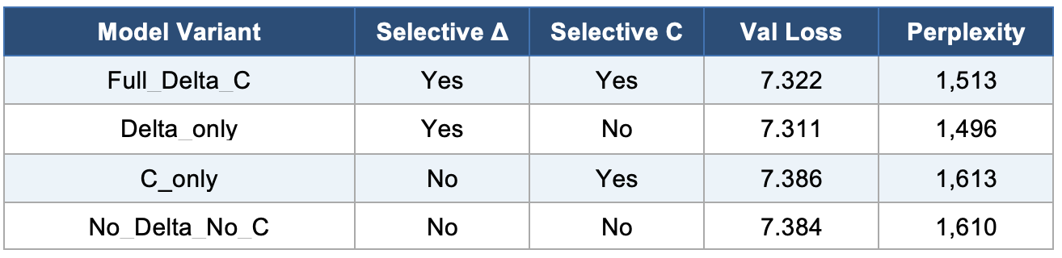
Table 4: Loss and Perplexity of four Model Variant

Reflection and Discussion
Overall, this project provided us the chance to learn about Mamba and interesting ideas about how modern sequence models operate beyond the basic Transformer. Initially, we approached Mamba as simply a more efficient alternative to Transformers, but through experimentation, it became clear that its advantages are not limited to computational efficiency. In particular, the robustness experiments show that Mamba’s selective state space mechanism fundamentally changes how the model processes information. Another important takeaway from this project is learning about the role of selective mechanisms, Delta and C. Through the ablation study, we observed that removing these components leads to a noticeable degradation in performance, especially in terms of perplexity.
However, our project still has some limitations. Because of computational constraints, we worked with relatively small models and limited training steps, which may have affected the stability and generalizability of our results. Also, our evaluation focused primarily on perplexity, accuracy and loss, without exploring more complex downstream tasks or qualitative analysis of generated text. As a result, for our future work, we would investigate larger-scale training and adding Multiple lengths sequence for Selective test for the ablation hypothesis. Also, we want to add more diverse benchmarks. Since, for our current steps, we only tested on a limited type of tasks (like QA or language modeling), but models can be used for many things, like translation or summarization. So we want to add new things and see if Mamba works well across different kinds of problems, not just one. Furthermore, even within the same task, different datasets can be very different. So we plan to use more different datasets to make our results more reliable and for better understanding our hypothesis and Mamba.

Code Repository
The codebase is accessible on GitHub: https://github.com/DQZ25/Mamba-Reimplementation/tree/main

Reference
[1] Gu, A. and Dao, T. (2024). Mamba: Linear-Time Sequence Modeling with Selective State Spaces. arXiv:2312.00752v2.
[2] Biderman, S. et al. (2023). Pythia: A Suite for Analyzing Large Language Models Across Training and Scaling. Proceedings of ICML.
[3] Jin, Q. et al. (2019). PubMedQA: A Dataset for Biomedical Research Question Answering. EMNLP-IJCNLP.
[4] Vaswani, A. et al. (2017). Attention Is All You Need. NeurIPS.

